develop a java program to create abstract vehicle with abstract methods calculate speed and calculate velocity create subclasses car and bike that extends vehicle class and implement respective methods
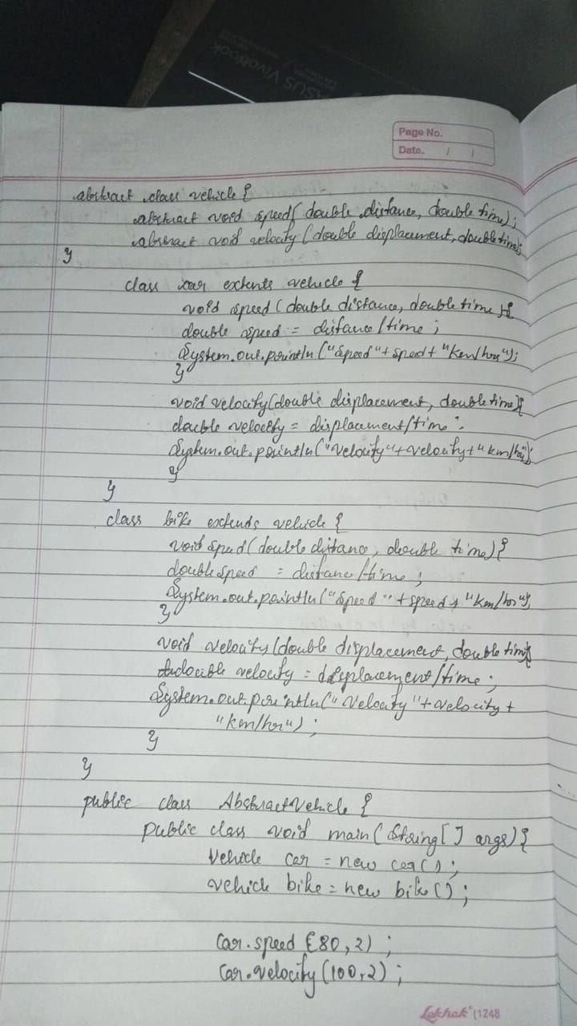
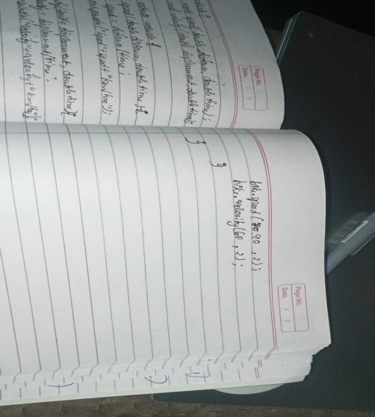
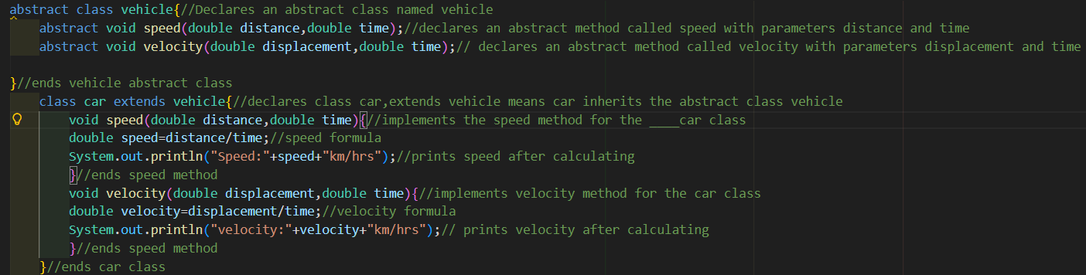
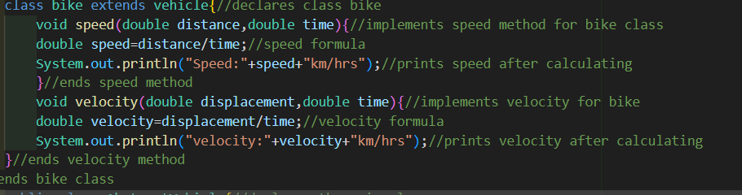
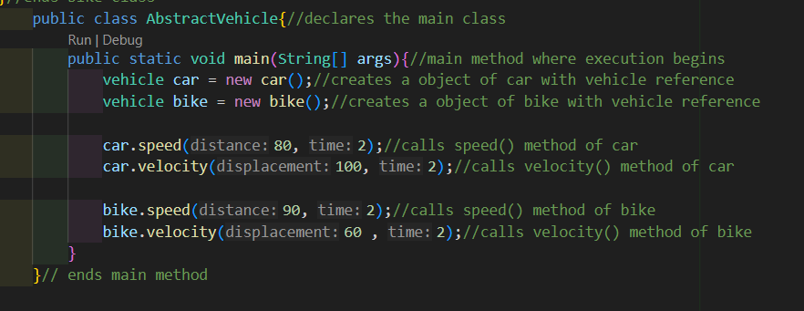

ERRORS
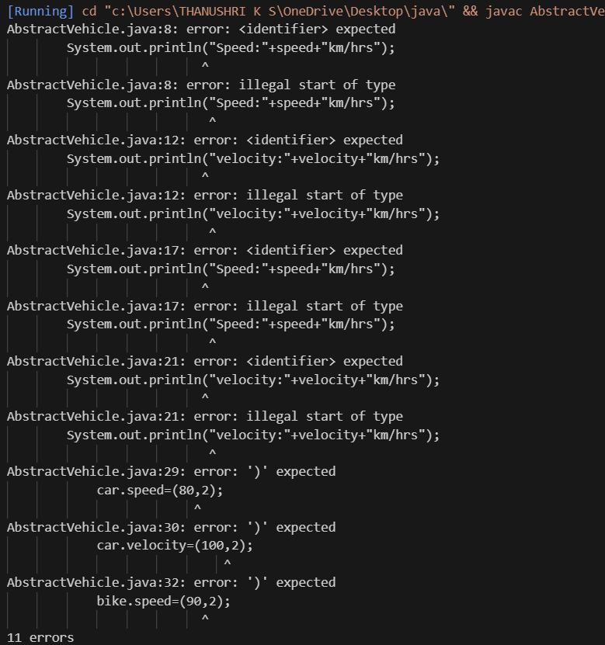
OUTPUT
